

Procedure for creating and using an NCAD PIN

Prepared by Thomas Duke

Introduction

The implementation of NCAD pins allow students and preceptors to seamlessly work on the same device without needing to log in and out repeatedly.
There are four sections on MyCAD which allow sign off using the Preceptor’s NCAD PINs. These are:
- Attendance Record
- Preliminary Interview
- Mid Interview (Long placements ONLY)
- Final Interview
This user guide should hopefully lay out the process for that as clearly as possible, as well as a step-by-step guide on how preceptors can create their own PIN. It is worth noting that the procedure itself is identical across all the above named sections.

Procedure
For the below example, I will be using the “Attendance Record” section.
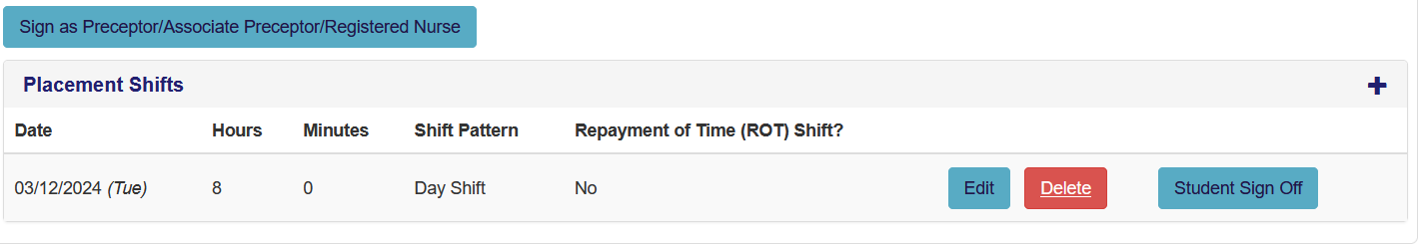
The student will add a shift in the normal manner and will then sign off. Once done, the Preceptor/Associate Preceptor/Registered Nurse has the option to sign off the record using the same device by clicking on the ‘Sign as Preceptor/Associate Preceptor/Registered Nurse’ at the top of the page.
To set up an ‘NCAD’ please follow the instructions below.
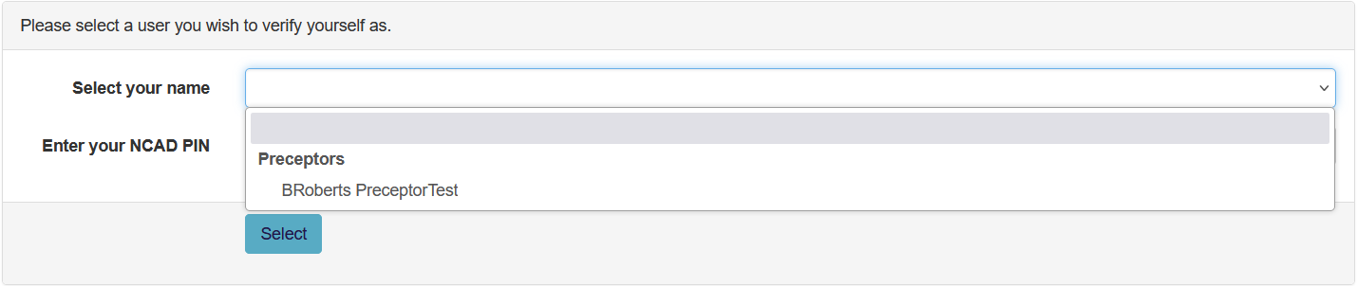
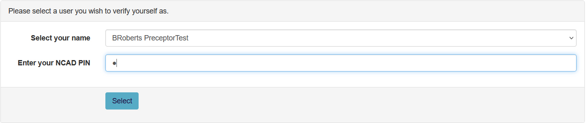
At this point, the student will hopefully have added a preceptor to their placement. If they have, the preceptor will be able to select their name from the dropdown list in the first screenshot. They will then need to enter their NCAD PIN. Once done, they should click ‘Select’.
They will then be granted access if the PIN that has been entered was correct. If incorrect, access will be denied, and they will be taken back to the previous page.
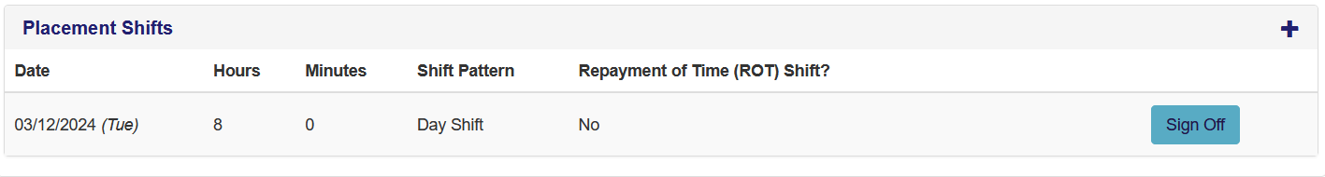
Once a preceptor has access to the student’s record, they will then need to sign off the record.
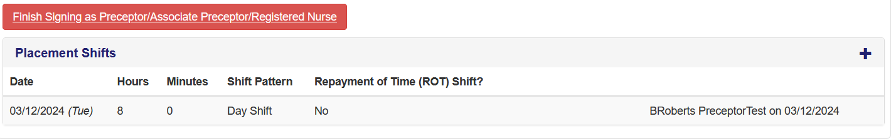
This then shows as having been signed off by the Preceptor who entered their PIN. Once all records that needed signing off have been completed, the preceptor will need to click the ‘Finish Signing as Preceptor/Associate Preceptor/Registered Nurse button. Once clicked, control will be handed back to the student.

Setting up a NCAD PIN
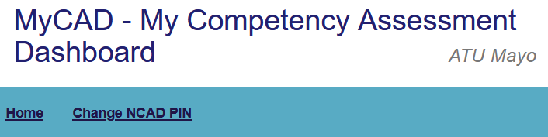
Upon logging in via the mycad.ie site, the preceptor will see on their dashboard homepage the above link titled ‘Change NCAD Pin’. This button allows the Preceptor/Associate Preceptor/Registered Nurse to create an NCAD Pin
If you want to change that NCAD PIN please follow the instructions below.

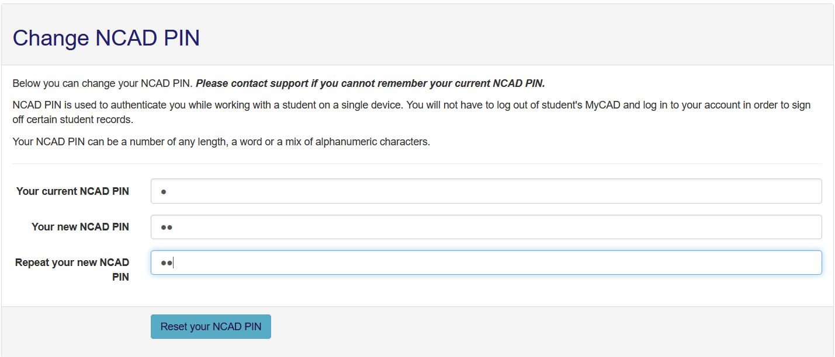
Here, the preceptor will need to input their current PIN first. Then, they will need to enter their new PIN and repeat it. Also note in the guidance text that Support should be contacted if a preceptor has forgotten their PIN. Once complete, click the ‘Reset your NCAD PIN’ button.
Once done, the page will refresh, and the preceptor will be returned to the homepage.

